CIVIC SERVICES PLATFORM: COMPLAINT MANAGEMENT SYSTEM
MILESTONE 2
Course: Software Engineering
Team 107
Team Members | Student ID
Ausha Murthy | 21f1006306
Paramveer Singh | 21f1006266
Utkarsh Omre | 23f3000151
Someshwar Srimany | 21f1002093
Shahzada Moon | 23f2002668
Ritesh Kumar Jha | 23f3002470


IITM Online BS Degree Program,
Indian Institute of Technology, Madras, Chennai
Tamil Nadu, India, 600036
1

Table of Contents
1. Design of Components 4
2. Class Diagram 13
3. Database Design Diagram 14
4. Sprint Schedule 15
5. Scrum Meetings Schedule and Minutes 20
6. Screenshot of Gantt Chart 21
7. Screenshot of Kanban Board 22
8. Screenshots of the Frontend pages have been developed. 22
9. Project Scheduling Tools Used 25

1. Design of Components
The Civic Services Platform is divided into several independent but interconnected components.
Each component is responsible for a specific business function derived from the user stories and
functional requirements identified during Milestone 1. The modular architecture improves
maintainability, scalability, and future enhancement of the system.
1. CITIZEN VIEW (APIs / Jobs)
o Register and sign in, scoped to a ward
o Create a new complaint (category, description, location, up to 5 images)
o Create a complaint by voice (record, auto-transcribe, edit before submit)
o Review and edit a complaint before submission
o Read own complaints (list, filter by open / in progress / resolved)
o Track a complaint lifecycle with a timestamp at each stage
o Read the assigned officer's name, department and contact number
o Read officer progress notes and before/after resolution photographs
o Rate a resolved complaint (1-5 stars, optional comment)
o A rating of 2 or below automatically reopens the ticket
o Receive a notification at every status change (background job)
2. FIELD OFFICER VIEW (APIs / Jobs)
o Read the department queue ordered by computed priority score
o Read tickets assigned to self
o Read a ticket in full (description, transcript, photos, address, map)
o Read the priority score breakdown (severity, days open, citizens
affected, weather context)
o Accept a ticket from the queue
o Update ticket status (open / in progress / resolved)
o Create a progress note visible to all reporting citizens
o Select the citizen photograph as the "before" image
o Upload the "after" photograph as resolution proof
o Close a ticket with a resolution note (sets resolved_at)
o Reassign a ticket to another officer with a recorded reason
o Set own availability status
3. MUNICIPAL CHAIRMAN VIEW (APIs / Jobs)
o Read city overview counts (open, in progress, resolved, average
resolution time, overdue)
o Read open complaint volume broken down by department
o Read high-priority and delayed cases (ticket, ward, score, days, status)
o Read duplicate clusters plotted on a city map
o Read officer performance (resolved count, average days, average rating)
o Read aggregate feedback metrics and recent citizen comments
o All chairman operations are read-only

4. ADMINISTRATOR VIEW (APIs / Jobs)
o Create, edit and deactivate service categories
o Configure category-to-department routing
o Configure SLA targets per department and severity
o Create and manage user accounts and roles
o Assign officers to departments and zones
o Set officer workload ceilings
5. BACKGROUND JOBS (no user interface)
o Duplicate detection - on every complaint creation, compare category,
geographic proximity and description similarity against open tickets
o Ticket merge - map a duplicate complaint to the existing main ticket and
recompute report and affected-citizen counts
o Ticket creation - when no duplicate is found, create a main ticket with
severity, department routing and SLA due date
o Priority scoring - recompute the score for every open ticket on a
schedule and on each relevant event (new duplicate, status change, day
rollover, SLA breach)
o Weather context fetch - cached call to an external weather service,
falling back to "normal" if unreachable
o Queue ranking - order tickets by final score, split per department
o Notification fan-out - push each status change to every reporting
citizen on the ticket, including merged duplicate reporters
o SLA monitoring - flag tickets past due_at as delayed
o Automatic reopen - return a ticket to open on the first rating of 2
stars or below

Components:
The Civic Services Platform is designed using a modular architecture consisting of several independent yet interconnected components. Each component is responsible for a specific business function identified from the user stories and functional requirements gathered during Milestone 1. This modular approach improves maintainability, scalability, reusability and enables future enhancements to the system.
The components work together to provide a seamless complaint management workflow. User Management authenticates users and controls access to system features. Complaint Management captures and stores complaints, which are processed by the Duplicate Detection component to prevent redundant records. Valid complaints are converted into tickets by the Ticket Management component, prioritised using the Priority Engine, and assigned to Field Officers through the Assignment component. Officers update complaint progress using the Status Update module, while the Notification component keeps citizens informed at every stage. After resolution, the Feedback component gathers citizen responses, and the Dashboard & Analytics component provides insights and performance metrics for municipal authorities. The Media Management component supports the entire workflow by storing images, audio recordings, and resolution evidence.

1. User Management Component
Purpose
- Manages all users of the system, including Citizens, Field Officers, Municipal Chairman, and Administrators.
Responsibilities
- User Registration
- Login & Authentication
- Role-based Authorization
- User Profile Management
- Department Assignment
Primary Users
- Citizen
- Field Officer
- Chairman
- Admin
Database Tables
- USER
- DEPARTMENT
Connected Components
- Complaint Management
- Assignment
- Dashboard
- Notification

2. Complaint Management Component
Purpose
- Enables citizens to register complaints and monitor them until they are resolved.
Responsibilities
- Submit Complaint
- Store Complaint Details
- Upload Images
- Voice-to-Text Complaint
- Track Complaint Status
- Complaint History
Inputs
- Category
- Description
- Location
- Images
- Voice Recording
Outputs
- Complaint ID
- Complaint Status
Database Tables
- COMPLAINT
- MEDIA
Connected Components
- Duplicate Detection
- Priority Engine
- Notification Service

3. Duplicate Detection Component
Purpose
- Detects whether a newly submitted complaint already exists in the system.
Responsibilities
- Compare Location
- Compare Category
- Compare Description
- Similarity Matching
- Merge Duplicate Complaints
Outputs
- Existing Ticket
- New Ticket
Benefits
- Reduces duplicate work
- Saves officer effort
- Maintains one master ticket
Connected Components
- Complaint Management
- Ticket Management

4. Ticket Management Component
Purpose
- Creates and manages the master ticket after duplicate detection.
Responsibilities
- Create Main Ticket
- Store Ticket Status
- Count Citizens Affected
- Maintain Resolution Timeline
- Department Mapping
Database Table
- TICKET
Connected Components
- Assignment
- Priority Engine
- Status Updates

5. Priority Engine Component
Purpose
- Automatically prioritizes complaints based on urgency.
Responsibilities
- Calculate Priority Score
- Analyze Severity
- Count Citizens Affected
- Check Officer Availability
- Consider Weather Context
- Rank Complaints
Priority Factors
- Severity
- Days Open
- Number of Reports
- Weather
- Officer Availability
Database Table
- PRIORITY_SCORE
Connected Components
- Ticket
- Assignment
- Dashboard

6. Assignment Component
Purpose
- Assigns complaints to the appropriate Field Officer.
Responsibilities
- Officer Assignment
- Reassignment
- Assignment History
- Active Assignment Tracking
Database Table
- ASSIGNMENT
Connected Components
- Ticket
- User
- Status Update

7. Status Update Component
Purpose
- Enables officers to update the progress of assigned complaints.
Responsibilities
- Change Status
- Upload Progress Notes
- Upload Resolution Proof
- Close Complaint
Status Values
- Open
- In Progress
- Resolved
Database Table
- STATUS_UPDATE
Connected Components
- Notification
- Feedback

8. Notification Component
Purpose
- Keeps citizens informed throughout the complaint lifecycle.
Responsibilities
- Complaint Submitted Notification
- Officer Assigned Notification
- Status Changed Notification
- Complaint Resolved Notification
- Feedback Reminder
Recipients
- Citizens
- Officers

9. Feedback Component
Purpose
- Collects citizen feedback after complaint resolution.
Responsibilities
- Rating
- Comments
- Satisfaction Analysis
- Reopen Request
Database Table
- FEEDBACK
Connected Components
- Dashboard
- Chairman Module

10. Dashboard & Analytics Component
Purpose
- Provides analytical reports and insights for administrators and municipal authorities.
Responsibilities
- High Priority Complaints
- Delayed Complaints
- Duplicate Clusters
- Officer Performance
- Citizen Feedback
- Complaint Statistics
Primary Users
- Chairman
- Department Heads
Connected Components
- Ticket
- Feedback
- Priority Engine

11. Media Management Component
Purpose
- Stores and manages all media files associated with complaints.
Responsibilities
- Complaint Images
- Voice Recordings
- Resolution Photos
- File Management
Database Table
- MEDIA

2. Class Diagram
The Class Diagram provides a visual representation of the system's object-oriented structure. It illustrates the classes, their attributes, methods, and the relationships between them, such as inheritance, association, and aggregation. This diagram acts as a blueprint for the application's software design and implementation.

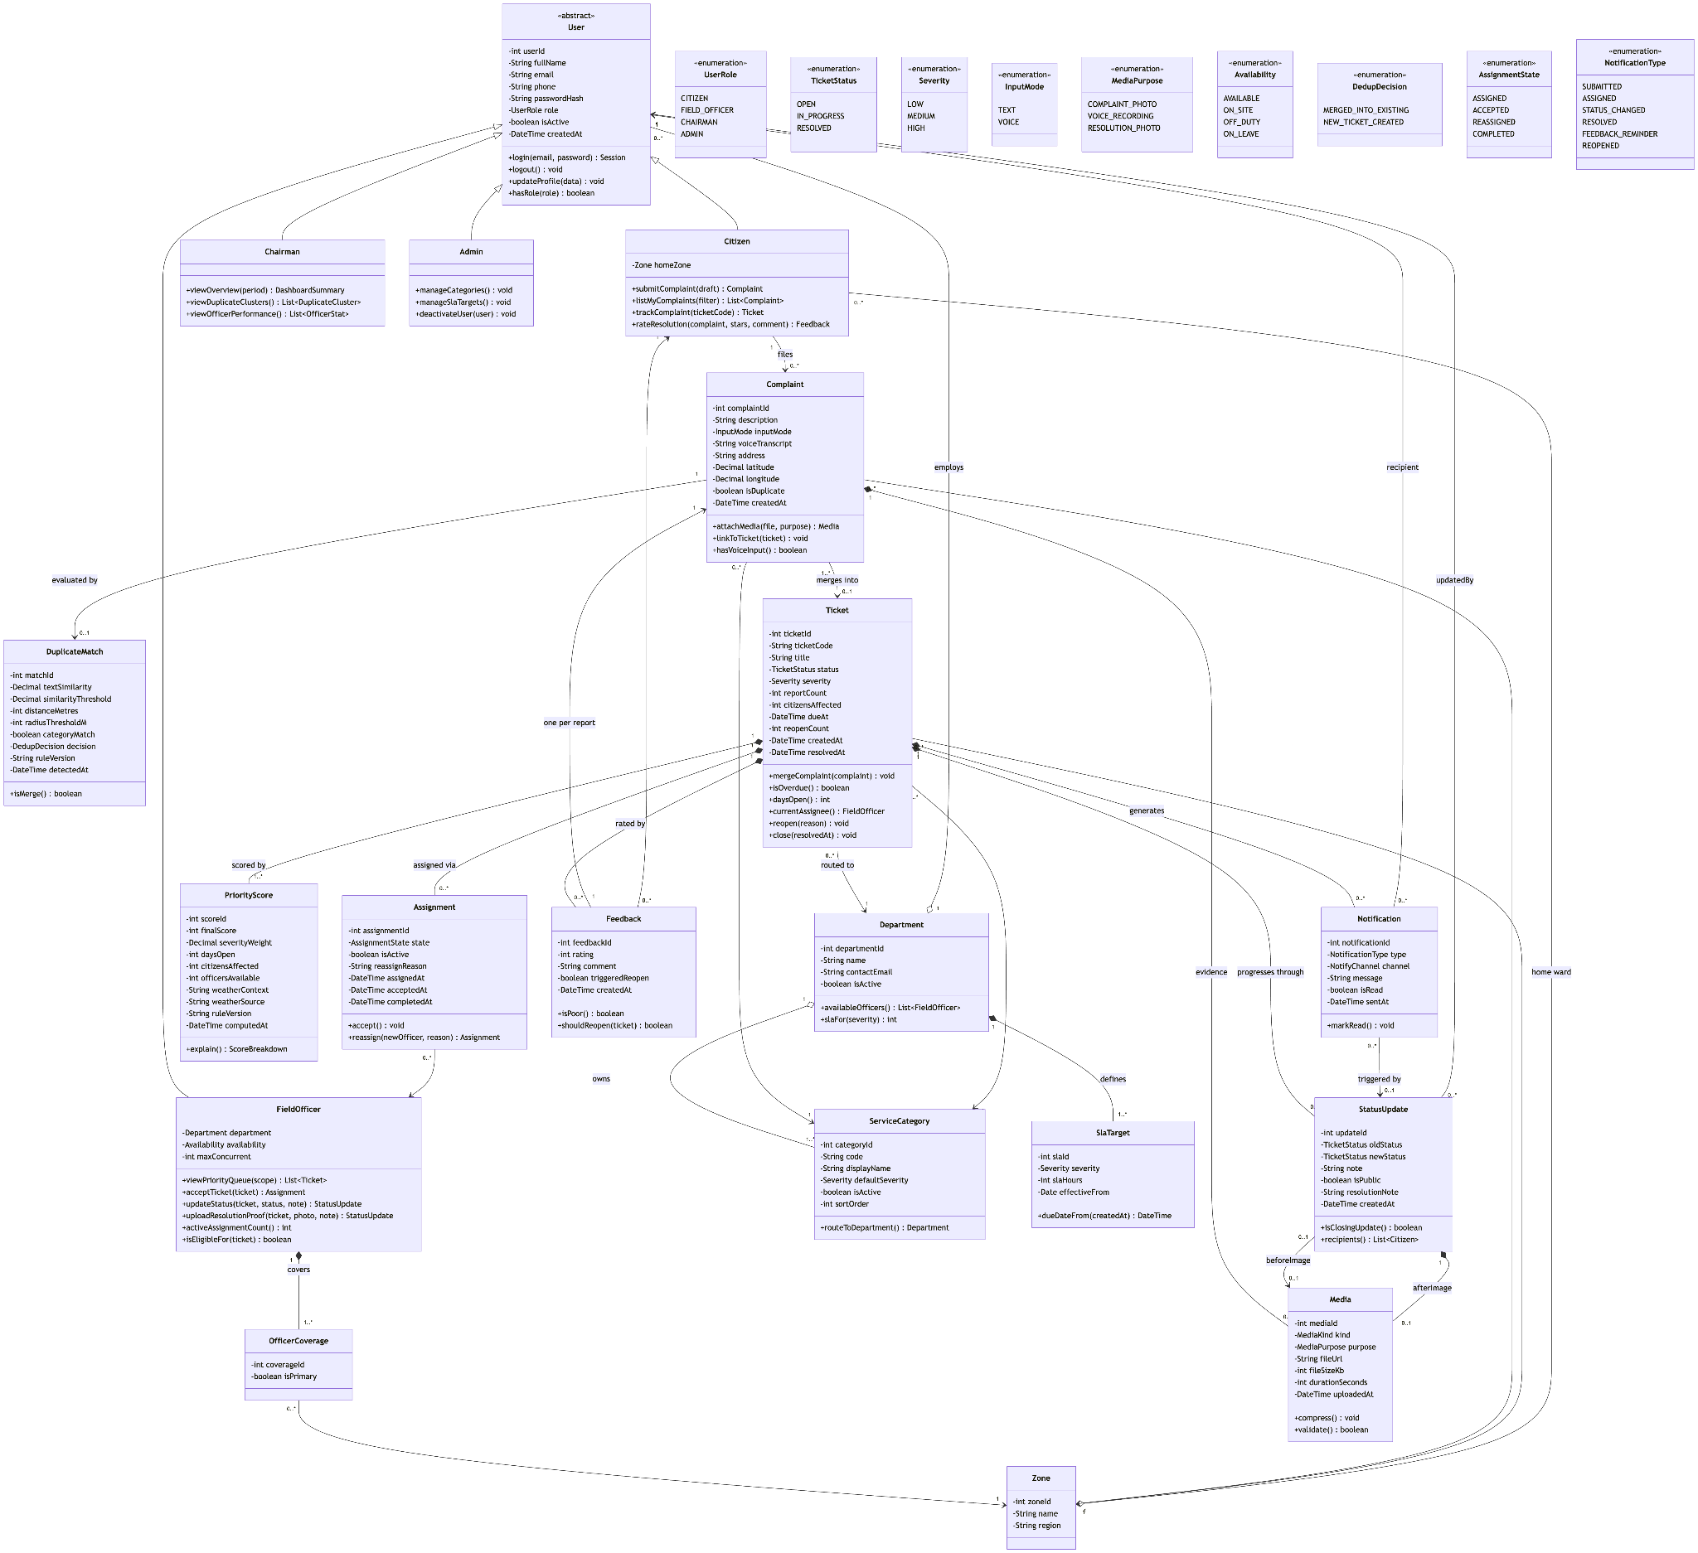
3

3. Database Design Diagram

The Database Design Diagram illustrates the structure of the application's database, including entities, attributes, primary keys, foreign keys, and their relationships. It ensures efficient data organization, minimizes redundancy, and supports reliable data storage and retrieval for the system.

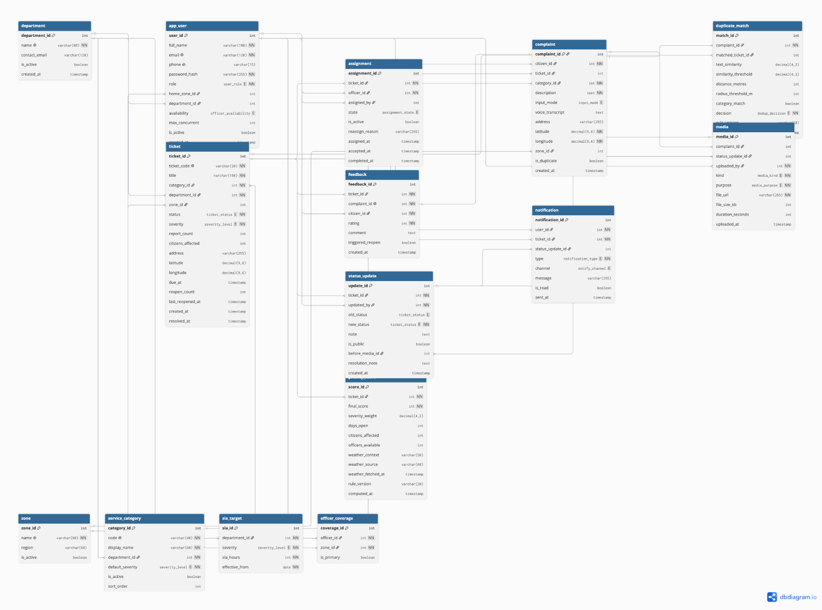

4. Sprint Schedule
The Sprint Schedule outlines the project's development timeline by dividing the work into manageable iterations. Each sprint includes specific objectives, tasks, and deliverables that help the team monitor progress, prioritise features, and achieve project milestones efficiently using Agile methodology.

1. Team Roster, Roles and Ownership
Team Member | Student ID | Role | Area of Ownership
Anusha Murthy | 21F1006306 | Product Owner | Product backlog, user stories, acceptance criteria, reporting, TA & client liaison
Someshwar Srimany | 21F1002093 | Scrum Master | Scrum ceremonies, meeting minutes, impediment tracking, design system, duplicate detection
Utkarsh Omre | 23F3000151 | Developer | Login & Sign-up, Authentication & Authorization
Shahzada Moon | 23F2002668 | Developer | Dashboard, Home pages, Application shell & Routing
Ritesh Kumar Jha | 23F3002470 | Developer | Field Officer & Chairman interfaces
Paramveer Singh | 21F1006266 | Developer | Citizen workflow and complaint submission
Note: All six team members participated in code reviews and sprint planning activities.

2. Project Scheduling Tools
Tool | Purpose
Jira Software | Sprint planning, backlog management, epics, user stories, story points, Kanban board
Jira Timeline | Gantt Chart and milestone planning
Google Meet | Scrum meetings, TA meetings, client discussions
GitHub | Version control, branching, pull requests and code reviews
dbdiagram.io | Database ER Diagram
Mermaid | Class Diagrams
Jira Configuration
- Project Key: CSP
- Board Structure: Five epics (CSP-1 to CSP-5), one for each course milestone.
- Issue Types: Epic, Story, and Task.
- Every user story and task is mapped to its respective milestone, allowing the Jira Timeline to function as the project's Gantt Chart.

3. Scrum Meeting Schedule

Ceremony | Schedule | Duration | Mode
Daily Stand-up | Every day before 10:00 PM IST | Async | Team Channel
Weekly Scrum | Saturday, 9:00 PM IST | 30 Minutes | Google Meet
Sprint Planning | First day of every Sprint | 30 Minutes | Google Meet
Sprint Review | Last day of every Sprint | 30 Minutes | Google Meet
Sprint Retrospective | Immediately after Sprint Review | 20 Minutes | Google Meet
TA / Client Meeting | Once every milestone | 30 Minutes | Google Meet

3.2 Meeting Calendar
Date | Time | Meeting | Sprint
22 Jun 2026 | 9:00 PM | Sprint 0 Planning | Sprint 0
27 Jun 2026 | 9:30 PM | TA Meeting 1 | Sprint 0
28 Jun 2026 | 9:00 PM | Sprint 0 Review & Retrospective | Sprint 0
29 Jun 2026 | 9:00 PM | Sprint 1 Planning | Sprint 1
04 Jul 2026 | 9:00 PM | Weekly Scrum | Sprint 1
11 Jul 2026 | 7:30 PM | TA Meeting 2 | Sprint 1
12 Jul 2026 | 9:00 PM | Sprint 1 Review & Retrospective | Sprint 1
13 Jul 2026 | 9:00 PM | Sprint 2 Planning | Sprint 2
19 Jul 2026 | 9:00 PM | Sprint 2 Review & Retrospective | Sprint 2
20 Jul 2026 | 9:00 PM | Sprint 3 Planning | Sprint 3
23 Jul 2026 | 9:00 PM | Sprint 3 Review & Retrospective (Milestone 2 Submission) | Sprint 3
24 Jul 2026 | 9:00 PM | Sprint 4 Planning | Sprint 4
26 Jul 2026 | 9:00 PM | Weekly Scrum | Sprint 4
02 Aug 2026 | 9:00 PM | Sprint 4 Review & Retrospective | Sprint 4
03 Aug 2026 | 9:00 PM | Sprint 5 Planning | Sprint 5
09 Aug 2026 | 9:00 PM | Weekly Scrum | Sprint 5
12 Aug 2026 | 9:00 PM | Sprint 5 Review & Retrospective | Sprint 5
13 Aug 2026 | 9:00 PM | Sprint 6 Planning | Sprint 6
16 Aug 2026 | 9:00 PM | Weekly Scrum | Sprint 6
23 Aug 2026 | 9:00 PM | Sprint 6 Review & Retrospective | Sprint 6

4. Sprint Numbering
Jira Sprint | Description | Course Sprint | Milestone
Sprint 0 | User Research | — | Milestone 1
Sprint 1 | Planning & Design | — | Milestone 2
Sprint 2 | Frontend Development | — | Milestone 2
Sprint 3 | Frontend Completion | — | Milestone 2
Sprint 4 | Backend & APIs | Course Sprint 1 | Milestone 3
Sprint 5 | Advanced Features | Course Sprint 2 | Milestone 4
Sprint 6 | Final Integration | — | Milestone 5

5. Milestone Calendar
Milestone | Epic | Due Date | Status
Milestone 1 – User Research | CSP-1 | 28 Jun 2026 | Completed
Milestone 2 – Design & Scheduling | CSP-2 | 23 Jul 2026 | Submitted
Milestone 3 – Backend & Core APIs | CSP-3 | 02 Aug 2026 | Planned
Milestone 4 – Additional Features | CSP-4 | 12 Aug 2026 | Planned
Milestone 5 – Final Integration | CSP-5 | 23 Aug 2026 | Planned

6. Sprint Breakdown
Sprint 0 – User Research (22 Jun – 28 Jun)
Goal
- Identify stakeholders
- Conduct interviews
- Prepare SMART user stories
Status: Completed

Sprint 1 – Planning & Design (29 Jun – 12 Jul)
Goal
- Set up Jira project
- Prepare Design of Components
- Database Design
- Sprint Planning
- Documentation
Status: Completed

Sprint 2 – Frontend Development (13 Jul – 19 Jul)
Goal
- Set up Vue application
- Build Login & Registration
- Citizen Complaint Submission
- Complaint Tracking
- Voice Complaint
- Feedback Module
Status: Completed

Sprint 3 – Frontend Completion (20 Jul – 23 Jul)
Goal
- Build Field Officer Dashboard
- Chairman Dashboard
- Notifications
- Routing
- Gantt Chart
- README
- Milestone 2 Report
Status: Completed

Sprint 4 – Backend & Core APIs
Planned Tasks
- Flask project setup
- Database migrations
- Swagger documentation
- API development
- User testing

Sprint 5 – Advanced Features
Planned Tasks
- Frontend–Backend Integration
- Testing
- User feedback
- Additional feature implementation

Sprint 6 – Final Integration
Planned Tasks
- End-to-end testing
- Bug fixing
- Deployment
- Final documentation
- Presentation
- Demo video
- Final project submission

5. Scrum Meetings Schedule and Minutes

Minutes of Meeting (Milestone 1, T.A. Meeting)(27.06.2026 9:30 pm -10:07 pm):
- We had brief introduction of everyone in the first 7 minutes
- We jumped straight down to what topic we chose as team and discussed about the users we identified
- Discussed about our problem statement and how would we be approaching it or what will the future of this application
- Tried figuring out the novelty and how are we providing a solution which doesn't exists and what our intends to do and how
- Tried understanding what are the different kinds of users in a application through a scenario given by our TA
- Had a discussion on team and task management through JIRA
- Discussed what are the deliverables of Milestone 1 and how to approach it
- Has a small doubt clearing session in extra time
- Ended the call on a high note and encouragement from TA

Minutes of Meeting (Milestone 2, T.A. Meeting)(11.07.2026 7:30 pm - 7:50 pm):
- We informed our TA that 2 members won’t be able to join the call due to other obligations.
- Our TA asked how milestone 1 was and we informed how we selected the primary users and what our final problem statement was.
- Discussed our approach and novelty in our system.
- ⁠Discussed and displayed the preliminary ER diagram and solution workflow.
- Had a doubt clearing session about the tech stack and limitations.
- Ended the call with encouragement from TA to go forward and start coding and assigning tasks.
Minutes of Meeting Scrum Meeting - 16.07.2026, Time: 10:00 PM – 11:00 PM
- Demonstrated completed frontend pages and gathered feedback.
- Discussed backend API endpoints required for integration.
- Updated the project documentation, including class diagrams and component descriptions.
- Verified that sprint tasks were progressing according to schedule.
Minutes of Meeting Scrum Meeting - 20.07.2026, Time: 7:00 PM – 7:40 PM
- Reviewed all completed tasks for Milestone 2.
- Verified the frontend pages, database design, and project documentation.
- Ensured the Kanban board and Gantt chart reflected the latest project status.
- Planned the next sprint focusing on backend implementation, testing, and system integration.

6. Screenshot of Gantt Chart

We’re generating this screenshot from our Jira board. The Gantt Chart provides a timeline-based overview of the project's activities, milestones, and deadlines. It visually represents task durations, dependencies, and project progress, enabling effective planning, monitoring, and resource allocation throughout the development lifecycle.

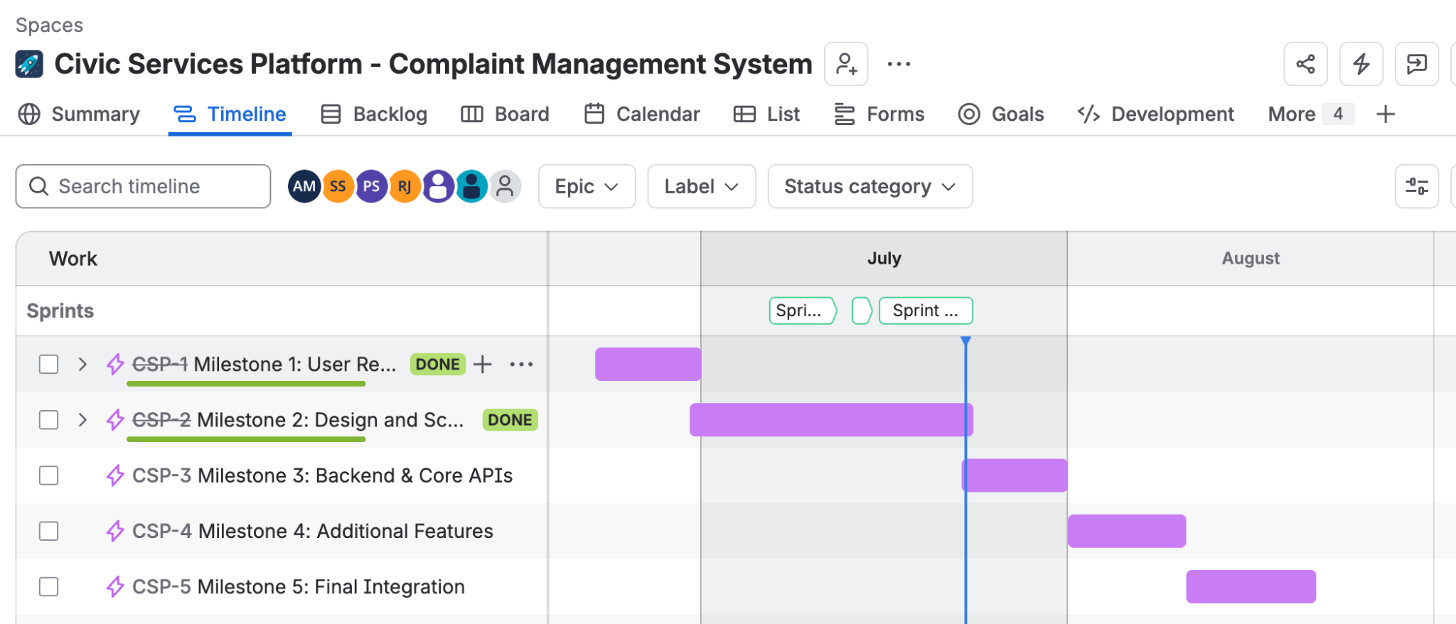

7. Screenshot of Kanban Board
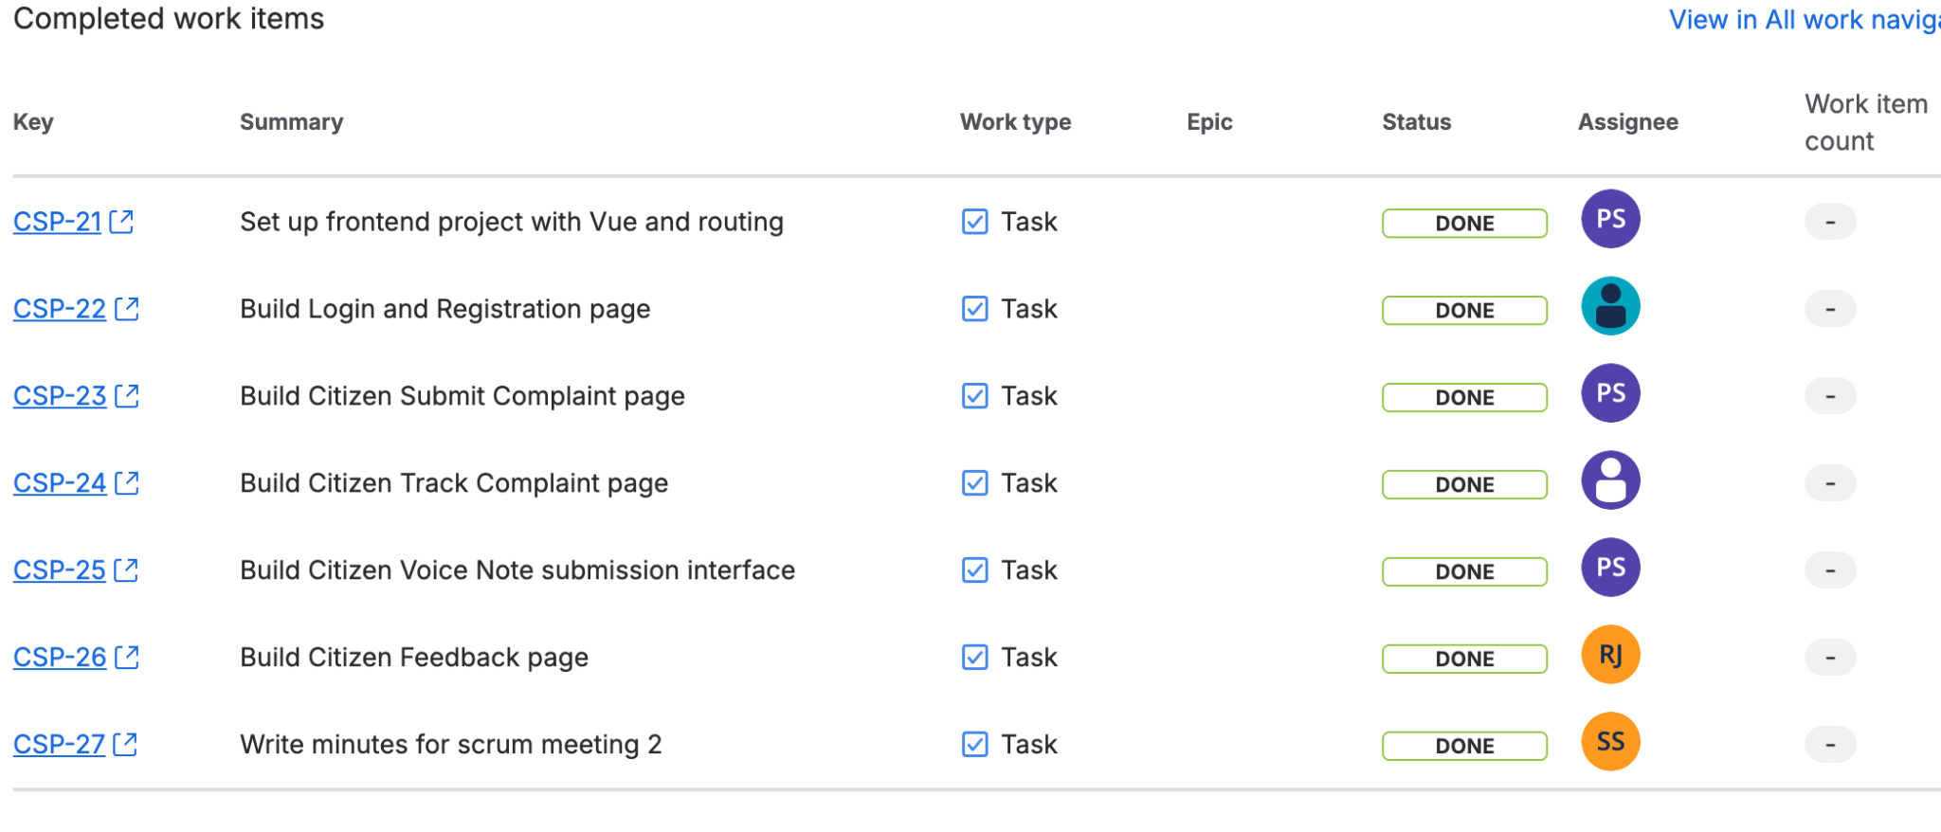

8. Screenshots of the Frontend pages have been developed.

App Home Page
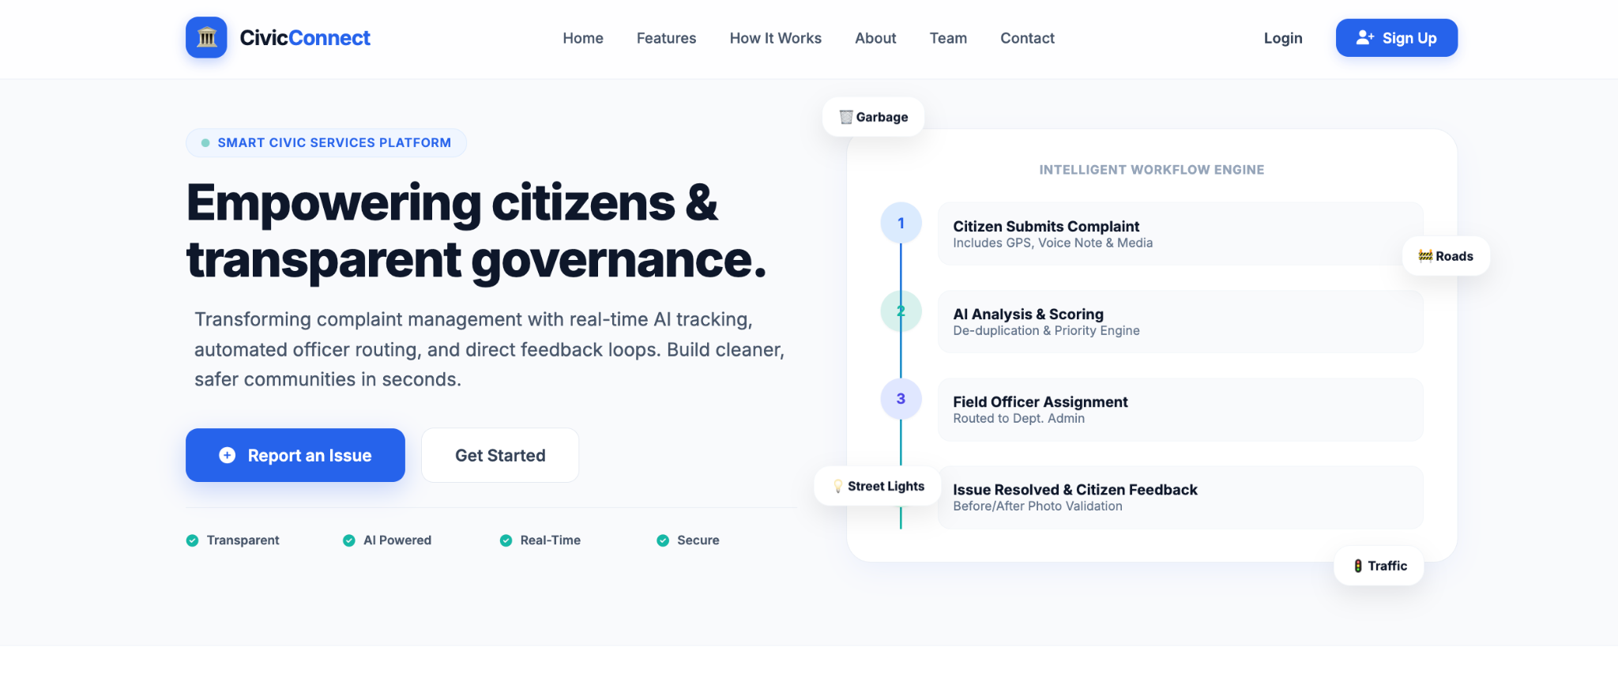
Registration Page
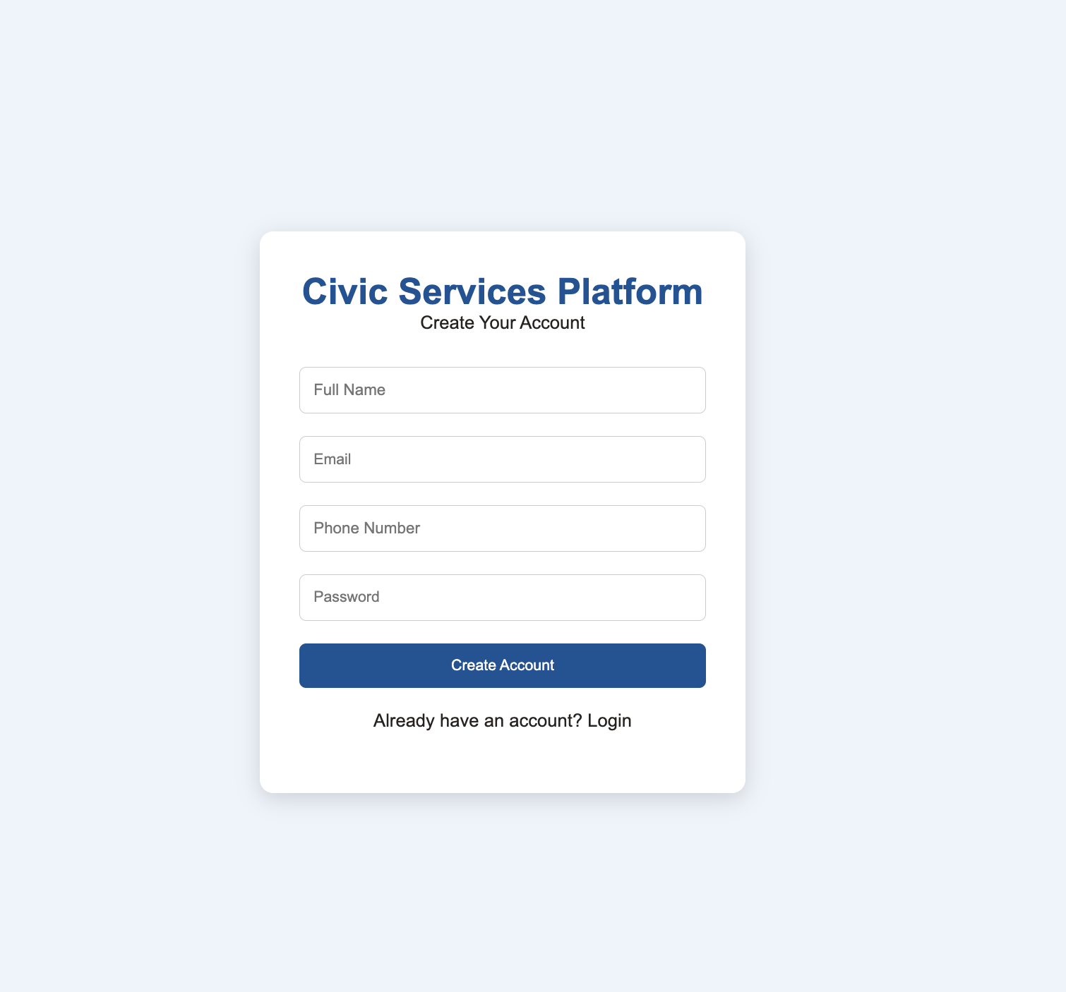

Citizen Dashboard Page
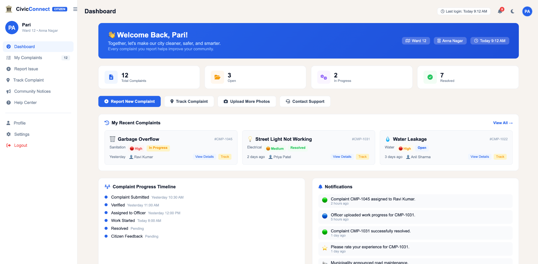
Complaint Priority Queue
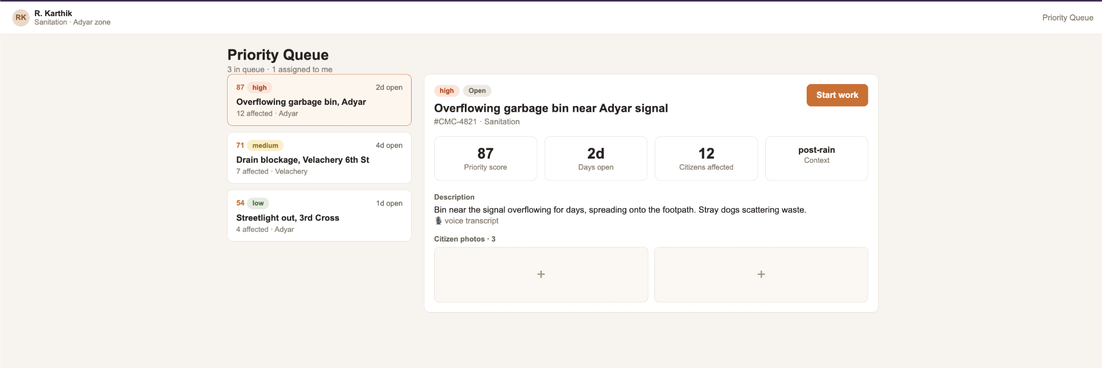
Complaint Cluster View
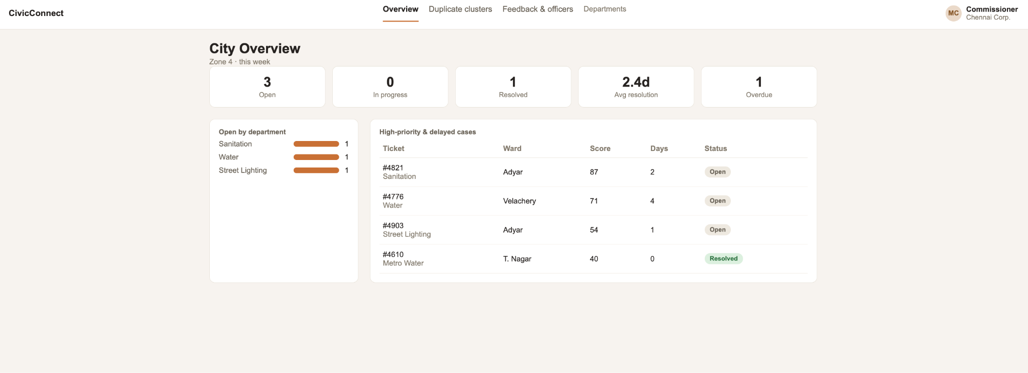
Feedback Page
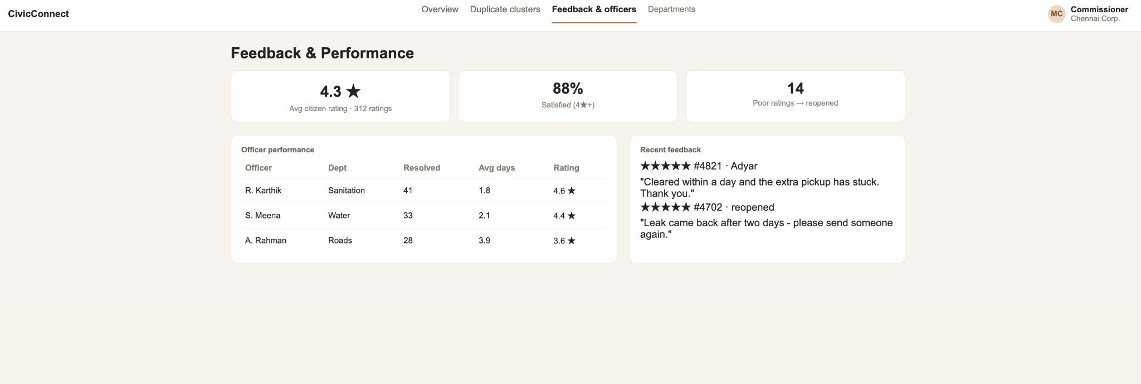

9. Project Scheduling Tools Used
To effectively manage the project using Agile methodology, our team utilized Jira as the primary project management and issue-tracking tool. Jira was used to create and manage sprint backlogs, assign tasks to team members, monitor progress, and track the status of user stories throughout the development lifecycle. The Kanban board and sprint planning features provided clear visibility into task ownership, priorities, and project progress, enabling efficient collaboration and ensuring that milestones were completed on schedule.
